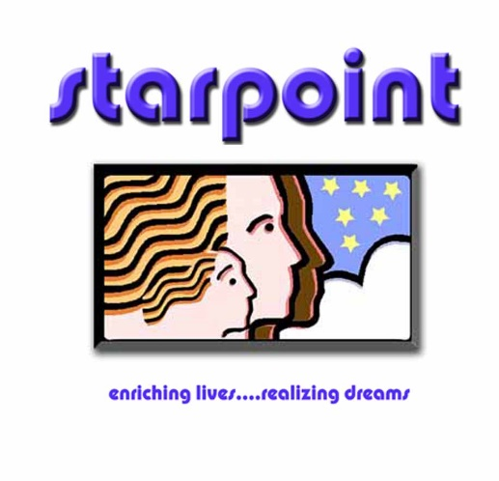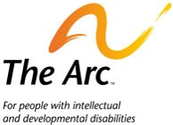

##### Free Training to Support Students with Disabilities

* Are you a parent, guardian, or friend of a loved one with a child with a disability?
* Is your student struggling with school?
* Do you have questions about the Special Education or IEP Process?
* Do you think your child needs an IEP in school?

**Topic: Principles of Individuals with Disabilities Education Act (IDEA) and the Individualized Education Program Process (IEP)**

**Date: Saturday, July 27th, 2019**

**Time: 10 AM – 1 PM**

**Light snacks provided**

**Place: Canon City Area Recreation and Park District Building**

**575 Ash St. Canon City, CO 81212**

This training is designed to give you an understanding of the principles of an Individualized Education Program (IEP) for a student receiving special education services under the Individuals with Disabilities Education Act (IDEA). Facilitated by the Arc of Pueblo, you will gain insight about the special education process for a student and how you can be involved, what to expect in an IEP team meeting and how to participate in the educational planning for your student.

**To register contact Alyssa Rogers at arogers@starpointco.com** [**or**](http://bit.ly/CSESP) **call 719-269-2252**