

***Spin North Newsletter…A program proudly brought to you by Starpoint***

##### March 2020

Hey Families!

This year is chugging right along. Spring break is here for our preschoolers. Preschool only kiddos will not have class March 16th through March 20th. We are continuing to do our monthly safety drills. If you are interested in knowing when we do those as well as being notified in a timely manner of a real even please look at the back page and sign up for the REMIND APP. Directions attached to the back of the newsletter. Brittany Connor, Center Director

“Make kindness an everyday practice for children, and see how humanity changes for the better.” – Childinsider.com

**Infants:**

This month we are continuing to work on our name cards with pictures. Pictures are a big part of our day please bring in your family pictures so that we can hang them up in class and talk to the children about them.

WE will be reading a lot of Dr. Seuss books this month as well as continuing those fun art projects.

Mrs. April & Ms. Bre

**Toddlers:**

Happy March! We cannot believe how fast February flew by!

We are excited to announce that we got three new friends from the infant room, so we are going to work on our routine. We will be making sure that our daily schedule is posted for the kids to see, and we will be referring to it often. We will also be talking about our expectations for the classroom and common areas around the school.

*****We do just want to remind you that we do go outside daily, please bring a jacket and hat for your kiddo as Colorado cannot make up its mind on what the day will be like. *****

Ms. Adriana & Mrs. Alicia

**Preschool Room 2:**

Our next study is called Exercise, where we will be talking about ways to be active and basic nutrition. We would love for visitors to come in and demonstrate their type of exercise! Whether you are into yoga, crossfit, sports, or anything else, let us know and you are welcome to come in and do a “class” with the kids!

Additionally in this unit, we will be learning about healthy food choices and will be making some simple recipes on various days. Please be on the lookout for a paper in your child’s cubby box listing ingredients we will need if you are willing to donate. We will have an ongoing list by the sign-in clipboard so you can see what has and has not been already brought in.

Please remember to always bring some sort of jacket with your child each day! Even if your weather app says sunny and 55, expectant weather could roll in at any moment. Hats and mittens are also recommended to keep at school. It’s Colorado, we could experience all four seasons within a day!

Mrs. Danielle & Mrs. Danielle

Ms. Lorene

**Kitchen:**

# Howdy Families!

# Well if March comes in like a lamb, it will go out like a lion… so let’s cross our finders for it to come in like a lion… I need nice weather! Pulling out an old family favorite for you today.

**Hamburger Macaroni Skillet**

Prep: 10 min Cook: 30 min Yields: 6-8 servings

Ingredients:

* 1 ½ pounds ground beef
* 2 cans (10 ¾ oz each) Condensed tomato soup, undiluted
* 2 cups uncooked elbow macaroni
* 2 cups frozen mixed vegetables
* 1 ¾ cup water
* 1 ½ to 2 teaspoons garlic powder
* 1 teaspoon dried basil
* ½ teaspoon dried oregano

Directions

1. In a large skillet, cook beef over medium heat until no longer pink; drain.
2. Stir in the soup, macaroni, vegetables, water, garlic powder, basil and oregano.
3. Bring to a boil. Reduce heat; simmer, uncovered, for 20 minutes or until macaroni is tender. Enjoy!!

Well until next month, see you at the kitchen door!

Tina Cook

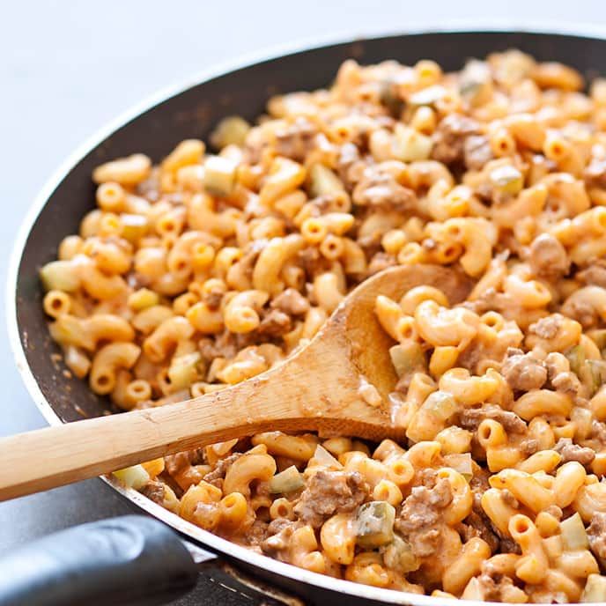

**Preschool Room 3:**

Thank you to everyone who helped with our friendship celebration. We enjoyed the day with music, stories and of course the ice cream sundaes. Thank you!

During March we will continue with the box study, as you can see we have lots of boxes of different sized around our classroom. The children are starting to see that boxes can be anything you want it to be. We had one friend turn her box into an airplane and invited her friend to go for a ride. If you or if you know someone that may have a fun and interesting box and would like to share it, we would love to see it!

REMINDER: There will be no preschool during the week of March 16-20, SPRING BREAK

Mrs. Christine & Mrs. Sami

SPIN NORTH EARLY CHILDHOOD CARE AND EDUCATION CENTER

March Menu

|  |  |  |  |  |
| --- | --- | --- | --- | --- |
| 2)**B**- WG Cereal, apple slices, milk  **L-**Baked ham with pineapple, cooked carrots, WG bread, milk  **S**-tortilla with cheese, water | 3)**B**-WG biscuits and gravy, orange slices, milk  **L**- Bean and cheese WG burrito, corn, mixed fruit, milk  **S**-cucumber WG sandwiches, water | 4)**B-**WG pancakes, applesauce, milk  **L**-Tuna Noodle Casserole, peas, pears, milk  **S**-saltines, cheese stick, water | 5)**B**-WG English muffin, cheese slice, banana, milk  **L**-Cowboy Grub w/ WG brown rice, cucumber, oranges, milk  **S**- Trail mix, milk | 6)**B**-cream of wheat, peaches, milk  **L**-Beef enchilada casserole, mixed veggies, apple slices, milk  **S**-celery w/ cream cheese, milk |
| 9)**B**-WG French toast, applesauce, milk  **L**-Hawaiian chicken, WG brown rice, pineapple, cooked carrots, milk  **S**-goldfish, milk | 10)**B**-scrambled eggs, WG tortilla, apples, milk  **L**-spaghetti w/meat sauce w/WG pasta, corn, mixed fruit, milk  **S**-cucumber, broccoli w/ ranch, water | 11)**B**-WG bagel w/cream cheese, banana, milk  **L**- tuna salad WG sandwiches, cucumbers, carrots, milk  **S**-pretzel rod with cheese sauce, milk | 12)**B**-WG English muffin w/sausage & cheese, apricots, milk  **L**-chicken fajitas w/ WG tortilla, corn, pears, milk  **S**-celery w/ sunflower butter, milk | 13)**B**-WG cereal, orange slices, milk  **L**-Beef Spanish WG brown rice, mixed veggies, applesauce, milk  **S**-yogurt, peaches, water |
| 16)**B**-WG bagel w/ cream cheese, pears, milk  **L-**chicken WG pasta salad, peas, pineapple, milk  **S**-goldfish and milk | 17)**B**-yogurt parfaits w/granola & peaches, milk  **L-**chili w/beef, WG crackers, carrots, oranges, milk  **S**-apples and cheese slices, water | 18)**B**-WG cereal, bananas, milk  **L**-Ham and beans, WG bread slice, green beans, mixed fruit, milk  **S**-WG tortillas w/ cheese. water | 19)**B**-WG biscuits and gravy, apples, milk  **L**-Turkey rollups w/WG tortillas, lettuce, tomato, cucumber slices, oranges, milk  **S**- WG toast and jelly, milk | 20)**B-** WG pancakes, applesauce, milk  **L-** beef enchilada casserole, WG saltines, corn, peaches, milk  **S-**  WG pretzels, milk |
| 23)**B**-oatmeal, applesauce, milk  **L**- Chicken salad WG sandwich w/cranberries, cucumber slices, oranges, milk  **S**-carrot sticks w/ranch, saltines, water | 24)**B**-WG English Muffin, mixed fruit, milk  **L-** beef & broccoli on WG brown rice, apples, milk  **S**- cottage cheese, pineapple, water | 25)**B**-WG cinnamon toast, bananas, milk  **L**-baked turkey, mashed potatoes, green beans, WG bread, milk  **S**-pretzels, milk | 26)**B-** scrambles eggs, toast, apricots, milk  **L-**WG tater tot casserole, cooked carrots, saltines, peaches, milk  **S**- WGtortillas w/ cheese slices, water | 27)**B-** WG French toast sticks, applesauce, milk  **L-** ham and cheese WG sandwiches, cucumber slices, apples, milk  **S-** trail mix, milk |
| 30) **B**-Yogurt parfaits w/ WG granola, pears, milk  **L**- Cheeseburgers on WG bun, tater tots, peaches, milk  **S**-pretzel twists, oranges, water | 31) **B**-WG waffles, applesauce, milk  **L**- Turkey Bacon Alfredo Skillet w/ WG rotini, peas, mixed fruit, milk  **S**-cottage cheese, pineapple, water |  |  |  |

**The U.S. Department of Agriculture prohibits discrimination against its customers, employees, and applicants for employment on the bases of race, color, national origin, age, disability, sex, gender identity, religion, reprisal, and where applicable, political beliefs, marital status, familial or parental status, sexual orientation, or all or part of an individual’s income is derived from any public assistance program, or protected genetic information in employment or in any program or activity conducted or funded by the department. (Not all prohibited bases will apply to all programs, the first 6 protected bases of race, color, national origin, age, disability and sex are the 6 protected bases for applicants and recipients of the child nutrition programs.)**

**If you wish to file a civil rights program complaint of discrimination, complete the USDA program discrimination complaint form, found online at** [**http://www.ascr.usda.gov/complaintfilingcust.html**](http://www.ascr.usda.gov/complaintfilingcust.html)**, or at any USDA office, or call (866) 632-9992 to request the form. You may also write a letter containing all of the information requested in the form. Send your completed complaint form or letter to us by mail at U.S. Department of Agriculture, Director, Office of Adjudication, 1400 Independence Ave., S.W., Washington, D.C. 20250-9410, by fax (202) 690-7442 or email at** [**program.intake@usda.gov**](mailto:program.intake@usda.gov)**. For individuals who are deaf, hard of hearing, have speech disabilities may contact USDA through the federal relay service at (800) 877-8339; (800) 845-6136 (Spanish) USDA is an equal opportunity provider and employer**

**All milk served to participants is unflavored, all participants 2 years and older are served low-fat (1%) milk and children under 1 year old are served whole milk WG- whole grain

