PROJECT #1: “Thank you, Essential Workers!”

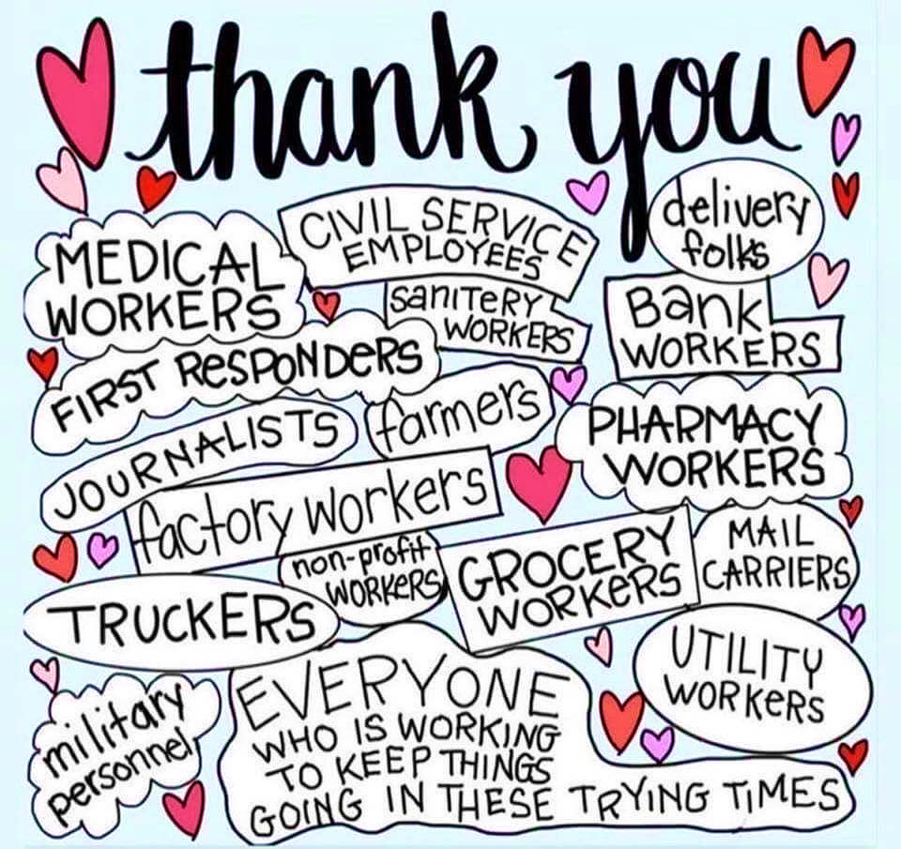
Let’s say “Thank You” to all the Men and Women still working to keep us safe, to keep us healthy, and to keep our lives running as normal as possible.
Instructions: Design a card that we can deliver to these wonderful individuals so they know just how much we appreciate all their efforts. Use your imagination and any materials you have available to create your card. If you do not have any materials, please come by Starpoint and there will be a bin outside this Monday/Wednesday from 7am-12pm. Please take ONE blank envelope containing basic supplies. If an envelope is already labeled with a name or house, then please do not take this. We have a very limited amount of supplies! Please bring your finished cards to Starpoint so they can be properly delivered, and don’t forget to snap a picture of yourself with the card so we can share it on Starpoint’s Facebook Page!

