Ursula Mbene
Time with Starpoint: 23 years
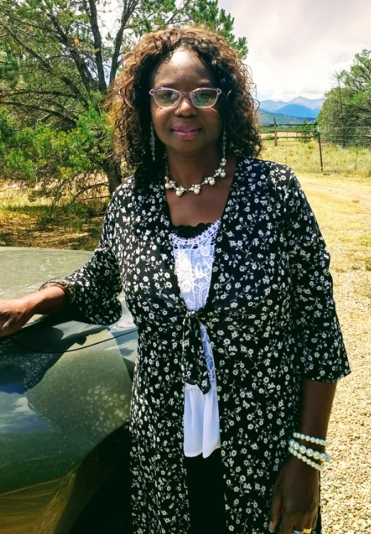

A finalist in Alliance Colorado’s Direct Support Professional of the Year Award 2021
Ursula was born and raised in Cameroon, a small country located in central and western Africa. At the age of 28, she came to the United States. Once she relocated to Colorado, she randomly came across a job in the newspaper advertising for a Direct Support Professional (DSP). She decided to find out exactly what that job entailed. Having a background in accounting, Ursula thought to herself, “I am trained to know numbers.” She accepted the job, knowing this would be a completely new experience. Prior to working at Starpoint, Ursula did not personally know anyone with intellectual or developmental disabilities.
Ursula likes challenges and works hard to succeed. When first taking on the role as a DSP, she pushed herself to learn quickly and immediately felt a connection to her new role. She found herself learning things she never imagined she would experience. She became tearful when expressing gratitude toward her longtime supervisor, Yvonne Bustos, for always having faith in her no matter the learning curve. She still has a letter written from Yvonne all those years ago commending her on her dedication to the job.
Currently, Ursula is Starpoint’s Special Habilitation Coordinator. Prior to COVID-19, Ursula would not describe herself as being technologically savvy. Once COVID-19 hit and the Day Program was closed, she worked tirelessly at mastering the various ways of teaching over zoom. She initially relied on co-worker and friend, April McManus, for guidance and as her confidence grew, she began teaching herself. She recalls thinking, “I can get it done.” It was incredible to observe her dedication to the process of learning a new skill. It wasn’t long before you would walk past her classroom and observe her teaching a well-attended and interactive zoom session.
When asked what she learned during the pandemic she replied, “this time has taught us that no matter the circumstance or situation, we can always make things good. We are working it. Zoom has been wonderful.”
Ursula has many talents that she shares with the consumers. She likes to cook/bake and makes special meals for the consumers and employees on Thanksgiving and St Patrick’s Day. She also hosts tea parties. When asked what her favorite part of the job is she replied, “I love coming up with fun activities and then watching faces light up with excitement.” She describes her greatest achievement during her 23 years with Starpoint as being able to walk alongside the individuals with whom she works and observing lives improve and individuals grow. She admires the fact that despite their disability, these individuals continue to strive. Ursula can still recall the names of the individuals she first worked with, of which made her smile.
When asked how she would describe an individual with intellectual and developmental disabilities she replied, “A person with a disability is just like everyone else. He/she is just born differently. I was raised to accept people for who they are and not to look at people as being different.” She then went on to say, “working at Starpoint has become the norm for me. It’s not like a job, it’s just what I do.
Ursula is a strong leader with a giving heart. Family means a lot to her. She volunteers at her church and is currently designing the nursery there. She decorates the church for all of the holiday and also sings soprano in the worship group. She wrote a song entitled, “Love Has No Pride,” of which has been made into a record by an artist from New York City. Ursula likes to sew, swim, and especially hike. She loves reading; particularly religious literature. Ursula is a pillar of Starpoint. She truly cares about the people she serves and always strives to be her best to lead by example. Though Ursula was trained to know numbers early in life, her heart now knows much more.

