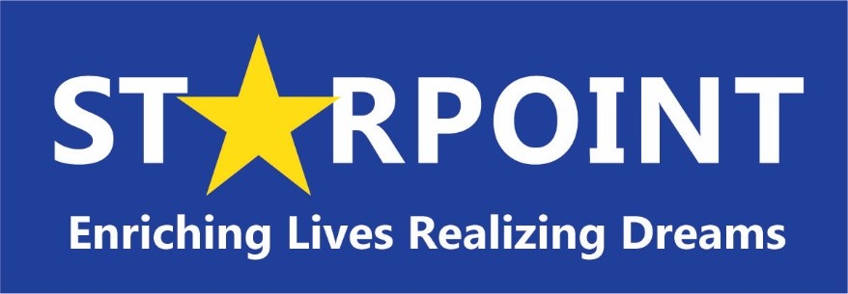
Serving Fremont, Chaffee and Custer Counties
700 S. 8th Street, Canon City CO 81212
Phone: 719-275-1616
Fax: 719-275-4619

Bryana Marsicano, Chief Executive Officer

Starpoint
Board of Directors Meeting Schedule
July 2022 – June 2023

Starpoint Board of Directors Meetings are held on the 4th Thursday of each month.

The November and December meetings are combined and usually held in early December. The date for the November/December combined meeting will be posted on our website after the October Board meeting in which the date is determined.

FY 22-23 meetings will be held on the Following Dates:

July 2022 | Thursday - July 28th, 2022
August 2022 | Thursday – August 25th, 2022
September 2022 | Thursday – September 22nd, 2022
October 2022 | Thursday – October 27th, 2022
November 2022/December 2022  Combined meeting | TBD – will be posted to website in October
January 2023 | Thursday – January 26th, 2022
February 2023 | Thursday – February 23rd, 2022
March 2023 | Thursday – March 23rd, 2022
April 2023 | Thursday – April 27th, 2022
May 2023 | Thursday – May 25th, 2022
June 2023 | Thursday – June 22nd, 2022

Visitors are welcome at all Starpoint Board of Directors meetings. There is a period for Public Comment for anyone wishing to speak during the meeting. Starpoint Board of Directors meetings begin at 6:00 PM. Board agendas are posted on the website prior to the Board of Directors meetings.

For More Information: Contact Jami Roy at 719-269-2210 or jroy@starpointco.com

