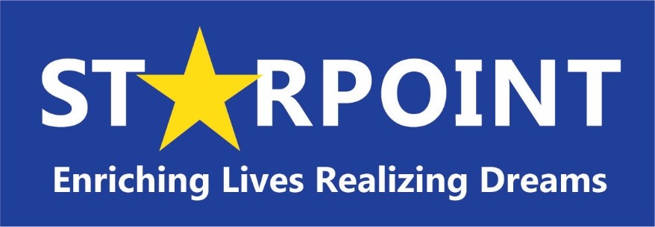
Serving Fremont, Chaffee and Custer Counties
700 S. 8th Street, Canon City CO 81212
Phone: 719-275-1616
Fax: 719-275-4619

Bryana Marsicano, Chief Executive Officer

Starpoint
Board of Directors Meeting
September 22nd, 2022 at 6:00 PM

Annual Meeting is held at The Abbey Event Center
2951 US 50, Canon City, CO 81212
Dinner for Board Members begins at 5:30 PM

Meeting Agenda
- Call to Order Board President

- Introduction of Guests and Public Comments Board President

- Action Item – Review and acceptance of Secretary
August Meeting Minutes

- Report – Financial Report Colette Martin

- Action Item – Approval of FY22-23 Budget Colette Martin

- Report – Chief Executive Officer Report and Updates Bryana Marsicano

- Report - Early Head Start – Board Report Martha Sager
- Adjourn Board President

